Chapter 8: Regression models for quantitative and qualitative predictors

8.1 Polynomial regression models

First-order model: E(Y_{i}) = β₀ + β₁X_{i1} = β₀ + β₁
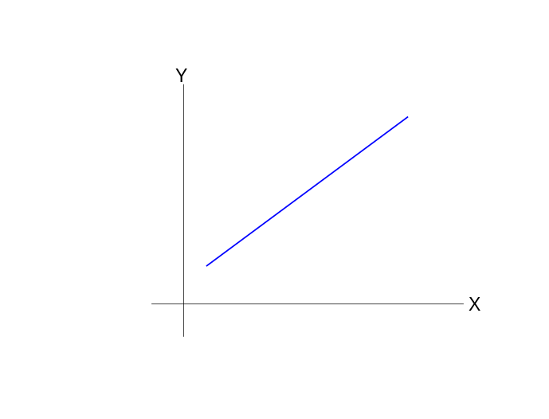
Second-order model: E(Y_{i}) = β₀ + β₁X_{i1} + β₂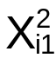
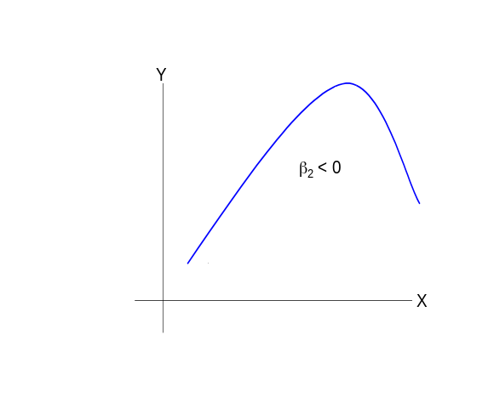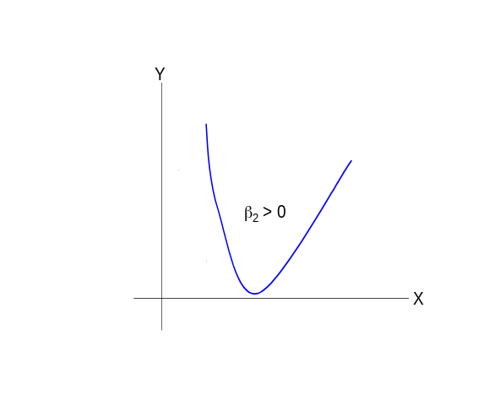

is called the second-order or “quadratic” term of the model. It allows for curvature in the relationship between X and Y.

The sign of β₂ determines if the curve opens upwards or downwards.

Since is a transformation of X_{i1}, these two model terms can be highly correlated leading to multicollinearity and problems with inverting X′X. To partially avoid this, the predictor variable can be transformed to be deviations from its mean, Z_{i1}=X_{i1}-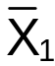. The second order model becomes, E(Y_{i}) = β₀ + β₁Z_{i1} + β₂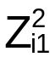.

Notes:
- KNN use a lowercase “script X” for Z here.
- Usually, I will only use this transformation when I see signs of multicollinearity and its effects of inferences. For example, if I see a VERY large standard error for a model coefficient when the transformation is not made, I will examine if this still occurs when the transformation is made.

Example: NBA guard data (nba_ch8.R)

Examine the age variable.

Some basketball fans may believe:
- Younger guards are learning the game and do not perform as well as more experienced guards
- Older guards performance decreases past a certain age
- Guards reach a peak performance level in their late 20’s.

In the above statements were true, one might expect to see a plot something like:
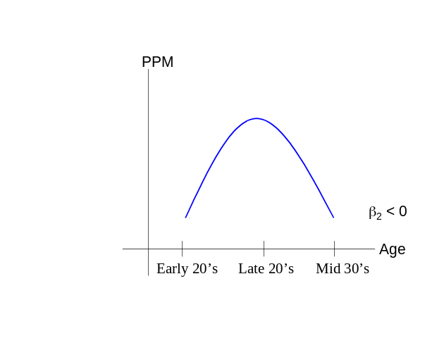

Consider the model E(Y_{i}) = β₀ + β₁X_{i1} + β₂ where Y_{i}=PPM and X_{i1}=Age. Also, consider the model E(Y_{i}) = β₀ + β₁Z_{i1} + β₂ where Y_{i}=PPM and Z_{i1}=X_{i1}-.

NOTE: The β's are NOT the same for the two different models! I used the "β" notation to be consistent with the notation used before. If you are uncomfortable with this notation, β′ could be substituted for β in the second model.

Fit the models and determine if Age² should be in the model.

R code and output:

> nba<-read.table(file =
"C:\\chris\\UNL\\STAT870\\Chapter6\\nba_data.txt",
header=TRUE, sep = "")

> mod.fit1<-lm(formula = PPM ~ age + I(age^2), data = nba)
> summary(mod.fit1)

Call:
lm(formula = PPM ~ age + I(age^2), data = nba)

Residuals:
Min 1Q Median 3Q Max
-0.255059 -0.083069 -0.001772 0.058228 0.396231

Coefficients:
Estimate Std. Error t value Pr(>|t|)
(Intercept) -0.6760076 0.7220455 -0.936 0.351
age 0.0802913 0.0514092 1.562 0.121
I(age^2) -0.0014443 0.0009053 -1.595 0.114

Residual standard error: 0.1155 on 102 degrees of freedom
Multiple R-Squared: 0.02634, Adjusted R-squared: 0.007247
F-statistic: 1.38 on 2 and 102 DF, p-value: 0.2563

> mod.fit2<-lm(formula = PPM ~ I(age-mean(age)) + I((age-
mean(age))^2), data = nba)
> summary(mod.fit2)

Call:
lm(formula = PPM ~ I(age - mean(age)) + I((age - mean(age))^2),
data = nba)

Residuals:
Min 1Q Median 3Q Max
-0.255059 -0.083069 -0.001772 0.058228 0.396231

Coefficients:
Estimate Std. Error t value Pr(>|t|)
(Intercept) 0.4397844 0.0151822 28.967 <2e-16 ***
I(age - mean(age)) 0.0007589 0.0036605 0.207 0.836
I((age - mean(age))^2) -0.0014443 0.0009053 -1.595 0.114
---
Signif. codes: 0 '***' 0.001 '**' 0.01 '*' 0.05 '.' 0.1 ' ' 1

Residual standard error: 0.1155 on 102 degrees of freedom
Multiple R-Squared: 0.02634, Adjusted R-squared: 0.007247
F-statistic: 1.38 on 2 and 102 DF, p-value: 0.2563

> mean(nba$age)
[1] 27.53333
> mod.fit2$coefficients
(Intercept) I(age - mean(age)) I((age - mean(age))^2)
0.4397843689 0.0007589219 -0.0014442934

> cor(x = nba$age, y = nba$age^2)
[1] 0.9978604
> cor(x = nba$age - mean(nba$age),
y = (nba$age- mean(nba$age))^2)
[1] 0.3960341

> plot(x = nba$age, y = nba$PPM, xlab = "Age", ylab =
"PPM", main = "PPM vs. Age", panel.first = grid(col
= "gray", lty = "dotted"))
> curve(expr = predict(object = mod.fit1, newdata =
data.frame(age = x)), col = "red", lty = "solid",
lwd = 1, add = TRUE, from = min(nba$age), to =
max(nba$age))
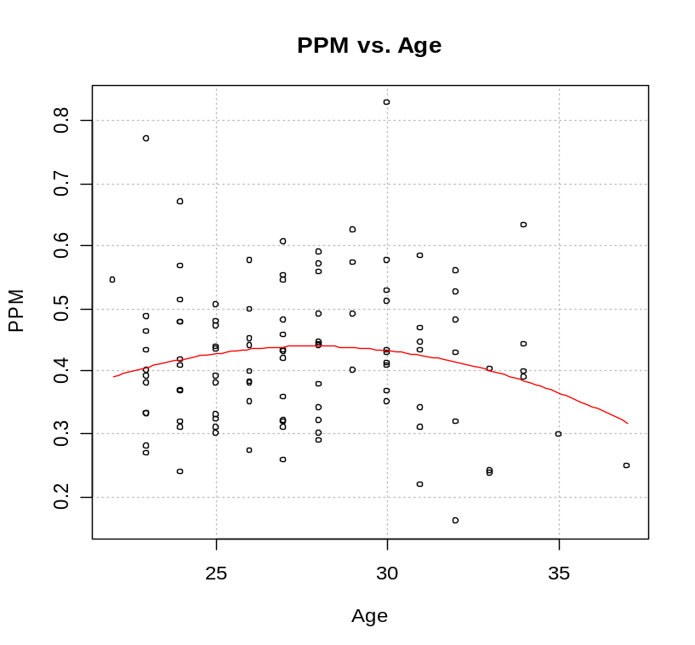

Notes:
- Notice how the I() (identity) function is used in the formula statements of lm(). The I() function helps to protect the meaning of what is inside of it. Note that just saying age^2 without the function will not work properly. We will see later on that syntax like (var1 + var2)^2 means to include var1, var2, and var1∗var2 in the model (all “main effects” and “interactions”). Thus, age^2 just means age to R because there are no other terms with it.
- The scale() function can also be used to find the mean-adjusted values. See example in program.
- There is strong positive correlation between age and age2. There is not as strong of correlation between the mean adjusted age terms.
- The sample regression model using the mean adjusted age variable is:
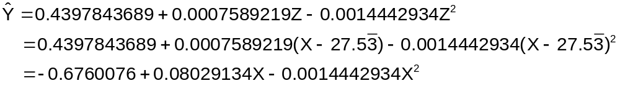
Therefore, the model using the transformed X (Z) is the same as just using X.
- The overall F test has a p-value of 0.2563 for both models indicating there is not a significant relationship between PPM and age, age². If the overall F test rejected H₀, then a test for age² would be appropriate to determine if there is a quadratic relationship between age and PPM.
- For illustrative purposes, the p-value for testing H₀:β₂ = 0 vs. H_{a}:β₂≠0 is 0.114 for both models. This would indicate there is marginal evidence that age² is needed.
- Given we received the same p-values for the overall F-test (shown in 5)) and both models are the same (shown in 4)), one does not need to worry about potential problems with using non-transformed predictor variables.
- The scatter plot with the sample regression model does not show a strong relationship between PPM and age.
- The interpretation of the b_{j} values can not be done the same way as before (i.e., for every one unit increase in X_{j},  increases by b_{j}). The age term itself is not interpreted directly due to the quadratic age term being present. Typically, one will just look at the sign on the squared term to determine if the sample model is concave up or down.
- More complicated models could be considered, like E(PPM) = β_{o} + β₁MPG + β₂Height + β₃FTP + β₄AGE + β₅AGE². To determine if there is a relationship between Age and PPM, partial F tests can be used to test: H₀:β₄=β₅=0 vs. H_{a}: At least one β≠0.

Estimation of E(Y) and prediction of Y with these types of models can be done in a similar manner as in the past. However, you need to be careful about how the predict() function is used. For example,

> #Predict at age = 20 with mod.fit1
> predict(object = mod.fit1, newdata = data.frame(age =
20))
[1] 0.3521019
> c(1,20,20^2)%*%mod.fit1$coefficients
[,1]
[1,] 0.3521019

Notice that age² did not need to be entered into the data.frame(). Next is an example of working with the transformation where R does not do the calculations as we would like.

> predict(object = mod.fit2, newdata = data.frame(age =
20)) #Incorrect answer
[1] 0.4397844

> c(1,20-mean(nba$age),(20-mean(nba$age))^2) %*%
mod.fit2$coefficients #Correct
[,1]
[1,] 0.3521019

> c(1,20,20^2)%*%mod.fit2$coefficients #Incorrect answer
[,1]
[1,] -0.1227545

> c(1,0,0)%*%mod.fit2$coefficients #Incorrect answer –
this is what predict()does above
[,1]
[1,] 0.4397844

The predict() finds I(age-mean(age)) due to the formula given in the lm() function and substitutes age = 20 everywhere age is given . This leads to values of 20 – mean(20) = 0.

To correct this problem, one needs to specify the model a little different in the lm() function:

> #Mean adjusting age - lm() part works AND predict()
part does as well
> mod.fit3<-lm(formula = PPM ~ I(age-mean(nba$age)) +
I((age-mean(nba$age))^2), data = nba)
> summary(mod.fit3)

Call:
lm(formula = PPM ~ I(age - mean(nba$age)) + I((age - mean(nba$age))^2), data = nba)

Residuals:
Min 1Q Median 3Q Max
-0.255059 -0.083069 -0.001772 0.058228 0.396231

Coefficients:
Estimate Std. Error t value Pr(>|t|)
(Intercept) 0.4397844 0.0151822 28.967 <2e-16 ***
I(age - mean(nba$age)) 0.0007589 0.0036605 0.207 0.836
I((age - mean(nba$age))^2) -0.0014443 0.0009053 -1.595 0.114
---
Signif. codes: 0 '***' 0.001 '**' 0.01 '*' 0.05 '.' 0.1 ' ' 1

Residual standard error: 0.1155 on 102 degrees of freedom
Multiple R-Squared: 0.02634, Adjusted R-squared: 0.007247
F-statistic: 1.38 on 2 and 102 DF, p-value: 0.2563

> predict(object = mod.fit3, newdata = data.frame(age =
20))
[1] 0.3521019
> c(1,20-mean(nba$age),(20-mean(nba$age))^2) %*%
mod.fit3$coefficients #Correct
[,1]
[1,] 0.3521019

Now, nba$age in the formula option tells R to always use the nba data.frame and pull out age. Alternatively, one could just find the mean of the ages before the lm() function and implement the following code:

mean.age<-mean(nba$age)
mod.fit4<-lm(formula = PPM ~ I(age-mean.age) +
I((age-mean.age)^2), data = nba)

What about the confidence interval for E(Y)? As you would expect, these are the same for the first (mod.fit1) and third (mod.fit3) ways to fit the model.

> #Compare C.I.s - notice they are the same
> predict(object = mod.fit1, newdata = data.frame(age =
20), se.fit = TRUE, interval = "confidence")
$fit
fit lwr upr
[1,] 0.3521019 0.2350136 0.4691902

$se.fit
[1] 0.0590313

$df
[1] 102

$residual.scale
[1] 0.1154669

> predict(object = mod.fit3, newdata = data.frame(age =
20), se.fit = TRUE, interval = "confidence")
$fit
fit lwr upr
[1,] 0.3521019 0.2350136 0.4691902

$se.fit
[1] 0.0590313

$df
[1] 102

$residual.scale
[1] 0.1154669

You may think that the first way would have a larger variance because the variability of the b_{j}’s is larger. However, since the covariances need to be incorporated, the same  is found. For the first model,

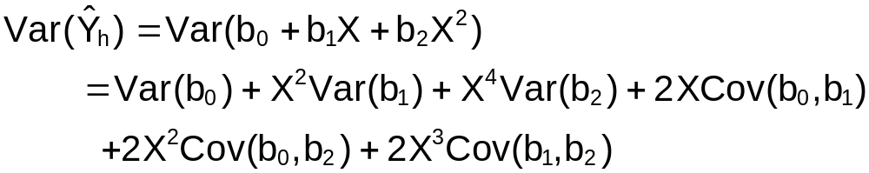
and for the third model,

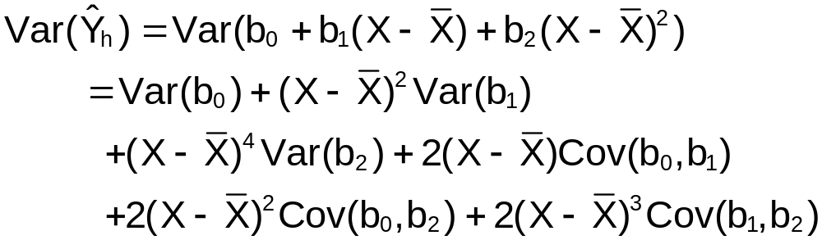

where b₀, b₁, and b₂ are defined for the particular model (thus, they are NOT the same). In matrix notation, we found the variance to be 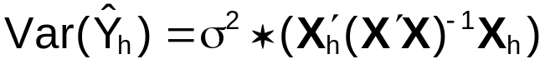 in general for X_{h} = (1, X, X²) or 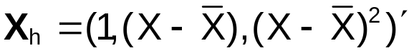. Using R to find the estimated quantities produces,

> #Examine estimated covariance matrices for b
> sum.fit1<-summary(mod.fit1)
> cov.b.fit1<-sum.fit1$sigma^2 * sum.fit1$cov.unscaled

> sum.fit3<-summary(mod.fit3)
> cov.b.fit3<-sum.fit3$sigma^2 * sum.fit3$cov.unscaled
> x<-20
> x.bar<-mean(nba$age)
> var.Y.hat.fit1<-cov.b.fit1[1,1] + x^2*cov.b.fit1[2,2] +
x^4*cov.b.fit1[3,3] + 2*x*cov.b.fit1[1,2] +
2*x^2*cov.b.fit1[1,3] + 2*x^3*cov.b.fit1[2,3]
> var.Y.hat.fit3<-cov.b.fit3[1,1] +
(x-x.bar)^2*cov.b.fit3[2,2] +
(x-x.bar)^4*cov.b.fit3[3,3] +
2*(x-x.bar)*cov.b.fit3[1,2] +
2*(x-x.bar)^2*cov.b.fit3[1,3] +
2*(x-x.bar)^3*cov.b.fit3[2,3]
> sqrt(var.Y.hat.fit1)
[1] 0.0590313
> sqrt(var.Y.hat.fit3)
[1] 0.0590313

> #Using matrices
> X.h<-c(1, 20, 20^2)
> X<-cbind(1, nba$age, nba$age^2)
> sqrt(as.numeric(sum.fit1$sigma^2)*X.h%*%solve(t(X)%*%X)
%*%X.h)
[,1]
[1,] 0.0590313

> X.adj.h<-c(1, 20-x.bar, (20-x.bar)^2)
> X.adj<-cbind(1, nba$age-x.bar, (nba$age-x.bar)^2)
> sqrt(as.numeric(sum.fit3$sigma^2)*X.adj.h
%*%solve(t(X.adj)%*%X.adj)%*%X.adj.h)
[,1]
[1,] 0.0590313

Second order models can become more complicated with additional predictor variables.

1) Third order model with 1 predictor variable:
E(Y_{i}) = β₀ + β₁Z_{i1} + β₂ + β₃

2) Second order model with 2 predictor variables:
E(Y_{i}) = β₀ + β₁Z_{i1} + β₂Z_{i2} + β₃Z_{i1}Z_{i2} + β₄ + β₅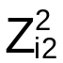

3) Second order model with 3 predictor variables:
E(Y_{i}) = β₀ + β₁Z_{i1} + β₂Z_{i2} + β₃Z_{i3} + β₄Z_{i1}Z_{i2} + β₅Z_{i1}Z_{i3} + β₆Z_{i2}Z_{i3} + β₇ + β₈ + β₉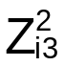

Notice the last two models above contain “interaction” terms. Along with the “squared” terms, these are considered to be second order model terms as well.

There is a hierarchical approach to fitting the regression model. For example, if β₃≠0 in 1), then and Z_{i1} are kept in the mode in addition to . See p. 299 of KNN for a discussion.

Residual plots should always be examined to evaluate the assumptions of the model. When a squared or higher order term is in the model corresponding to Z₁, only the plot of e_{i} vs. Z_{i1} needs to be examined for the “linearity” assumption. This is because e_{i} vs. , e_{i} vs. , … give the same information as e_{i} vs. Z₁

See p.300 of KNN for an example of a second order model with two predictor variables.

Example: NBA data (nba_ch8.R)

Consider the following model: E(PPM) = β₀ + β₁MPG + β₂Age + β₃Age∗MPG + β₄MPG² + β₅Age². Find the corresponding sample regression model and perform a partial F test to determine if a second order model should be used instead of a first order model. Use α=0.05.

Below is the R code and output. Note how I got the interaction term in the model.

> mod.fit.comp<-lm(formula = PPM ~ age + MPG + age:MPG +
I(age^2) + I(MPG^2), data = nba)
> sum.fit.comp<-summary(mod.fit.comp)
> sum.fit.comp

Call:
lm(formula = PPM ~ age + MPG + age:MPG + I(age^2) + I(MPG^2), data = nba)

Residuals:
Min 1Q Median 3Q Max
-0.18857 -0.07244 -0.01223 0.05517 0.30057

Coefficients:
Estimate Std. Error t value Pr(>|t|)
(Intercept) 1.1943663 0.7416479 1.610 0.110490
age -0.0332123 0.0512598 -0.648 0.518535
MPG -0.0335019 0.0090391 -3.706 0.000347 ***
I(age^2) 0.0002166 0.0008646 0.251 0.802680
I(MPG^2) 0.0003221 0.0001150 2.800 0.006142 **
age:MPG 0.0008442 0.0003401 2.482 0.014746 *
---
Signif. codes: 0 '***' 0.001 '**' 0.01 '*' 0.05 '.' 0.1 ' ' 1

Residual standard error: 0.09997 on 99 degrees of freedom
Multiple R-Squared: 0.2916, Adjusted R-squared: 0.2558
F-statistic: 8.149 on 5 and 99 DF, p-value: 1.787e-06

> sum.fit.comp$sigma^2
[1] 0.009994667

> mod.fit.red<-lm(formula = PPM ~ age + MPG, data = nba)
> summary(mod.fit.red)

Call:
lm(formula = PPM ~ age + MPG, data = nba)

Residuals:
Min 1Q Median 3Q Max
-0.199997 -0.072681 -0.004975 0.051162 0.409765

Coefficients:
Estimate Std. Error t value Pr(>|t|)
(Intercept) 0.422674 0.088204 4.792 5.63e-06 ***
age -0.003906 0.003209 -1.217 0.226
MPG 0.004461 0.001097 4.068 9.35e-05 ***
---
Signif. codes: 0 '***' 0.001 '**' 0.01 '*' 0.05 '.' 0.1 ' ' 1

Residual standard error: 0.1084 on 102 degrees of freedom
Multiple R-Squared: 0.1414, Adjusted R-squared: 0.1245
F-statistic: 8.396 on 2 and 102 DF, p-value: 0.0004211

> anova(mod.fit.red, mod.fit.comp)
Analysis of Variance Table

Model 1: PPM ~ age + MPG
Model 2: PPM ~ age + MPG + age * MPG + I(age^2) + I(MPG^2)
Res.Df RSS Df Sum of Sq F Pr(>F)
1 102 1.19927
2 99 0.98947 3 0.20980 6.9971 0.0002568 ***
---
Signif. codes: 0 '***' 0.001 '**' 0.01 '*' 0.05 '.' 0.1 ' ' 1

> p<-length(mod.fit.comp$coefficients) #Number of betas
in model is p
> g<-length(mod.fit.red$coefficients)-1 #Number of
variables remaining in the
reduced model is g
> qf(p = 0.95, df1=p-1-g, df2=mod.fit.comp$df.residual)
[1] 2.696469

- H₀: E(PPM) = β₀ + β₁MPG + β₂Age
H_{a}: E(PPM) = β₀ + β₁MPG + β₂Age + β₃Age∗MPG + β₄MPG² + β₅Age²

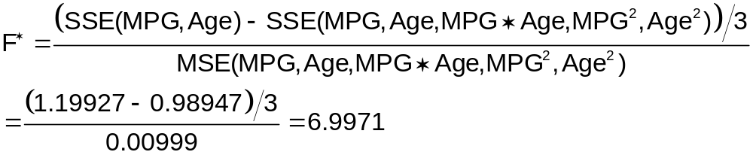

- F(0.95, 3, 99)=2.69647
- Since 6.9971>2.7, reject H₀
- At least one of MPG², Age², and MPG∗Age are important to the model.

The p-value of 0.0002568 could be used more simply as well.

A 3D scatter plot of the data with the regression plane is shown below.

library(Rcmdr)
library(rgl)
rgl.clear("all") #Clears plot window
rgl.light() #Gray background
rgl.bbox() #Puts numbers on plot and box around it
scatter3d(formula = PPM ~ age + MPG, data = nba,
fit="quadratic", grid=TRUE, xlab="age",
ylab="PPM", zlab="MPG", bg.col="black")
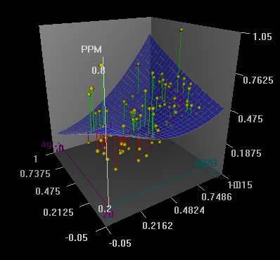

One can also put both the first and second-order models on the plot by using c(“linear”, “quadratic”) for the fit option.

8.2 Interaction regression models

The effect of one predictor variable on the response variable depends on another predictor variable.

Example: Suppose there are two predictor variables

Consider the first order model: E(Y_{i})=β₀+β₁X_{i1}+β₂X_{i2}. The effect of X₁ on E(Y) is measured by β₁.

Consider the model E(Y_{i})=β₀+β₁X_{i1}+β₂X_{i2}+β₃X_{i1}X_{i2}. The effect of X₁ on E(Y) is measured only by β₁ and β₃X_{i2}. Since X₂ is a predictor variable, the effect of X₁ on E(Y) is dependent on X₂. Similarly, the effect of X₂ on E(Y) is dependent on X₁. Thus, we say there is an “interaction” between X₁ and X₂.

For a model containing an interaction term, the regression function is no longer a flat plane.

Example: NBA data (nba_ch7.R)

Find the estimated regression model for E(PPM) = β₀ + β₁MPG + β₂Age + β₃MPG∗Age.

R code and output:

> mod.fit.inter<-lm(formula = PPM ~ age + MPG + age:MPG,
data = nba)
> summary(mod.fit.inter)

Call:
lm(formula = PPM ~ age + MPG + age:MPG, data = nba)

Residuals:
Min 1Q Median 3Q Max
-0.181469 -0.086163 -0.004787 0.052240 0.344910

Coefficients:
Estimate Std. Error t value Pr(>|t|)
(Intercept) 1.0710195 0.2037211 5.257 8.19e-07 ***
age -0.0279646 0.0075348 -3.711 0.000338 ***
MPG -0.0264535 0.0089165 -2.967 0.003756 **
age:MPG 0.0011338 0.0003248 3.491 0.000715 ***
---
Signif. codes: 0 '***' 0.001 '**' 0.01 '*' 0.05 '.' 0.1 ' ' 1

Residual standard error: 0.1029 on 101 degrees of freedom
Multiple R-Squared: 0.2338, Adjusted R-squared: 0.2111
F-statistic: 10.27 on 3 and 101 DF, p-value: 5.806e-06

> library(lattice)
> save.xyz<-expand.grid(age = min(nba$age):max(nba$age),
MPG = floor(min(nba$MPG)):ceiling(max(nba$MPG)))
> save.xyz$PPM.hat<-predict(object = mod.fit.inter,
newdata = save.xyz)

> win.graph(width = 8, height = 6, pointsize = 10)
> wireframe(PPM.hat ~ age + MPG, data = save.xyz, scales
= list(arrows = FALSE), drape = TRUE,
colorkey = TRUE, aspect = c(0.7, 0.3))
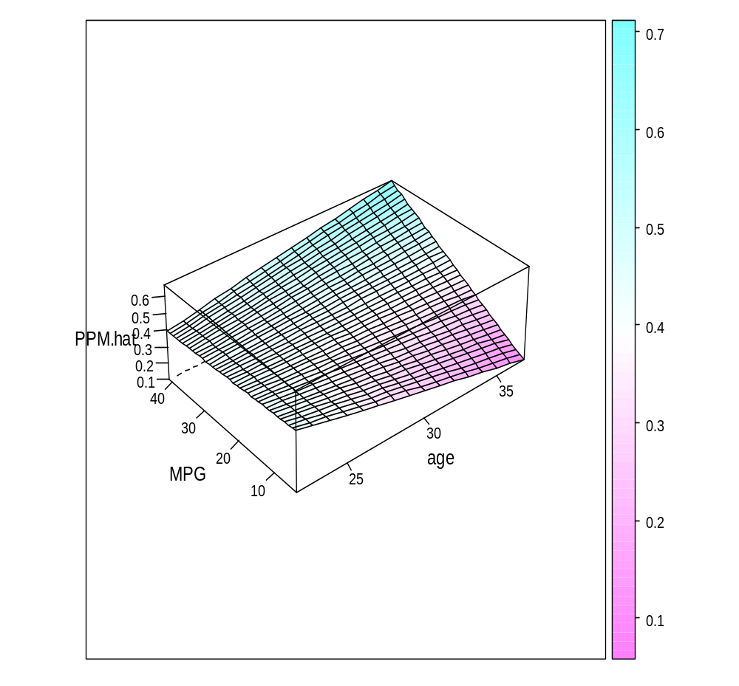

> wireframe(PPM.hat ~ age + MPG, data = save.xyz, scales =
list(arrows = FALSE), drape = TRUE,
colorkey = TRUE, aspect = c(1.3, 0.6))

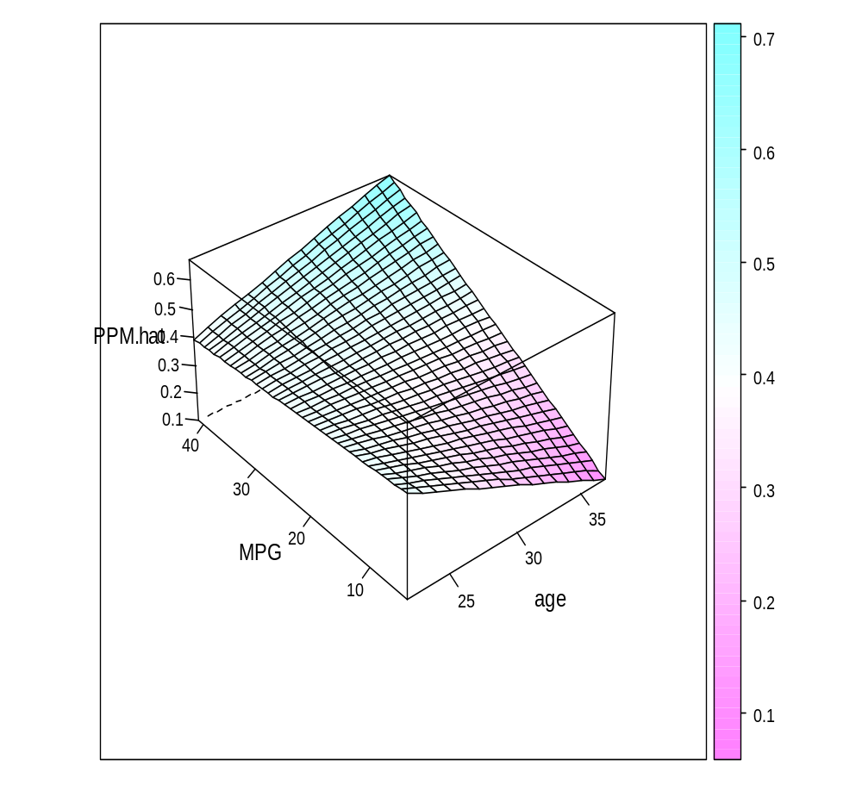
Notes:
- The interaction term is represented as age*MPG in the formula statement of lm(). There are other ways to represent this as well.

> mod.fit.inter1<-lm(formula = PPM ~ age + MPG + age:MPG,
data = nba)
> mod.fit.inter1$coefficients
(Intercept) age MPG age:MPG
1.071019547 -0.027964607 -0.026453471 0.001133794

> mod.fit.inter2<-lm(formula = PPM ~ age*MPG, data = nba)
> mod.fit.inter2$coefficients
(Intercept) age MPG age:MPG
1.071019547 -0.027964607 -0.026453471 0.001133794

> mod.fit.inter3<-lm(formula = PPM ~ (age+MPG)^2, data =
nba)
> mod.fit.inter3$coefficients
(Intercept) age MPG age:MPG
1.071019547 -0.027964607 -0.026453471 0.001133794

age*MPG – this puts both the interaction AND the “main-effects” (first-order terms) into the model. Thus, our original use in the formula statement of

formula = PPM ~ age + MPG + age * MPG

was actually redundant. R recognizes this and adjusts it accordingly.

age:MPG – this puts ONLY the interaction term into the model. Notice in the output how R states the interaction as age:MPG.

(age+MPG)^2 – this also puts the interaction AND the main-effects into the model. Note that (age+MPG+var3)^3 would put in all main-effects, all two-way interactions, and the three-way interaction into the model.
- The sample model is 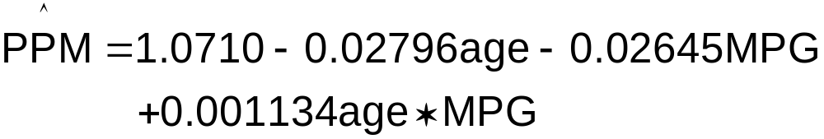
- The interaction term is significant.
- The estimated regression model is not a flat plane. Some people call it a “twisted” plane. I was unable to adjust the scatterplot3d() or the scatter3d() functions to construct the plot.

Sometimes problems with multicollinearity can occur when interaction terms are in the model. Similar to polynomial models, a transformation of Z_{ij}=X_{ij}- can be done to partially remedy the problem.
8.3 Qualitative predictors

Quantitative variables – Variables measured on a numerical scale.

Example: Height measured in inches

Qualitative variables – Variables that can not be measured on a numerical scale (i.e. measured on a categorical scale).

Example: Gender – Male or female

Code the data values for qualitative variables with indicator variables (0 or 1)

Example: Gender

X = 1 if female (F)
0 if male (M)

Notice there is only one indicator variable for 2 levels (male or female) of the qualitative variable; however, each level was a unique coding.

Suppose the model is E(Y) = β₀ + β₁X.

If X = 0 (Male), then E(Y) = μ_{M} = β₀.
If X = 1 (Female), then E(Y) = μ_{F} = β₀ + β₁.

where μ_{M} and μ_{F} are the mean of the response variable for male and female, respectively.

Then, μ_{F} - μ_{M} = β₀ + β₁ - β₀ = β₁

This means that the t-test for a hypothesis test of H₀:β₁=0 is equivalent to a hypothesis test for
H₀:μ_{F} - μ_{M}=0 (hypothesis test for differences between means of independent samples).

The model is simply a one-factor (or one-way) analysis of variance model. You may be more used to seeing the model in the form of

E(Y) = μ + α_{i} for i = 1, 2

where μ is the grand mean and α_{i} represents the “effect” of the i^{th} treatment level. In this setting, one often will let α₁ = 0 for identifiability purposes. Then E(Y) = μ for i = 1 and E(Y) = μ + α₂ for i = 2. Notice how this matches up with E(Y) = β₀ and E(Y) = β₀ + β₁ shown previously. Thus, a regression model with one qualitative variable is equivalent to a one-factor ANOVA model!

Example: Political party affiliation (Republican, Democrat, and Independent)

X₁ =1 if Republican, 0 otherwise
X₂ =1 if Democrat, 0 otherwise

Notice there are only two indicator variable for 3 levels (Republican, Democrat, and Independent) of the qualitative variable; however, each level was a unique coding.

Party | X₁ | X₂
Republican | 1 | 0
Democrat | 0 | 1
Independent | 0 | 0

Suppose the model is E(Y) = β₀ + β₁X₁ + β₂X₂. Note that this is a special case of a multiple linear regression model. The first subscript on X denotes the observation number, and the second subscript denotes the variable number. The hypothesis test for H₀:β₁=β₂=0 uses a F-test which is equivalent to the F-test for H₀:μ_{R}=μ_{D}=μ_{I} in a one-factor, completely randomized design, ANOVA model. Since political party affiliation is ONE variable, a F-test must be used to determine if it is an important variable. T-tests only test one indicator variable at a time. DO NOT PERFORM INDIVIDUAL T-TESTS FOR INDICATOR VARIBALES!

Note:
Republican: E(Y) = β₀ + β₁
Democrat: E(Y) = β₀ + β₂
Independent: E(Y) = β₀

In general, if there are c different levels for a qualitative variable, then c-1 indicator variables are needed. No matter what you choose as the coding for the indicator variables (Republican, Democrat, or Independent is the “all 0 level”), you will get the same and hypothesis tests involving the indicator variables will be the same.

Example: Car Highway MPG (car_mpg.R)

Estimate the highway MPG for cars based on their class.

Below is a partial listing of a data set that contains MPG and other information about 1998 cars.

Obs. | Make | Model | MPG | Class | Trans. | Engine | Cylinders | Speed
1 | Acura | 2.5TL/3.2TL | 25 | Compact | L | 2.5 | 5 | 4
2 | Acura | 2.5TL/3.2TL | 24 | Compact | L | 3.2 | 6 | 4
3 | Acura | 3.5RL | 25 | Mid-Size | L | 3.5 | 6 | 4
 |  |  |  |  |  |  |  | 
376 | Volvo | V70 | 20 | Station Wagon | L | 2.4 | 5 | 4

Response Variable | MPG: Highway miles per gallon
Predictor Variables | Trans.: transmission type with M=Manual, A=Automatic, and L=Automatic Lockup
Predictor Variables | Speed: number of gears
Predictor Variables | Engine: engine size (liters)
Predictor Variables | Cylinder: number of cylinders for the engine
Predictor Variables | Class: the class of car with levels of two-seater, minicompact, subcompact, compact, mid-size, large, and station wagon.

The data is stored in an Excel file called car_data98.xls. The file can be read into R using the following code:

> library(RODBC)
> z<-odbcConnectExcel("C:\\chris\\UNL\\STAT870\\
Chapter8\\car_data98.xls")
> car.data<-sqlFetch(z, "Sheet1")
> close(z)
> head(car.data)
Obs Model Make MPG Class Transmission Engine Cylinders Speed Abbr
1 1 2.5TL/3.2TL Acura 25 Compact L 2.5 5 4 P
2 2 2.5TL/3.2TL Acura 24 Compact L 3.2 6 4 P
3 3 3.5RL Acura 25 Mid-Size L 3.5 6 4 P
4 4 2.3CL/3.0CL Acura 28 Sub-Compact L 3.0 6 4
5 5 Integra Acura 31 Sub-Compact L 1.8 4 4
6 6 Integra Acura 31 Sub-Compact M 1.8 4 5

Suppose we are interested in the MPG by class. Below is a box plot with a dot plot overlay:

> boxplot(formula = MPG ~ Class, data = car.data, main =
"Dot plot for MPG by class", ylab = "MPG", xlab =
"Class", pars = list(outpch=NA))
> stripchart(x = car.data$MPG ~ car.data$Class, lwd = 2,
col = "red", method = "jitter", vertical = TRUE, pch =
1, xlab = "Class", ylab = "MPG", main = "Dot plot for
MPG by class", add = TRUE)
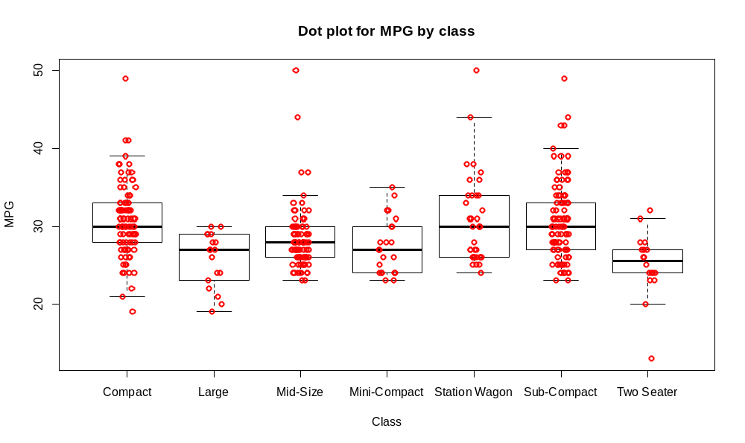

Are there differences in the mean MPG among car classes?

Some summary statistics:

> aggregate(formula = MPG ~ Class, data = car.data, FUN =
mean)
Class MPG
1 Compact 30.73118
2 Large 25.72222
3 Mid-Size 28.35632
4 Mini-Compact 27.50000
5 Station Wagon 30.81081
6 Sub-Compact 30.67327
7 Two Seater 25.11111

> aggregate(formula = MPG ~ Class, data = car.data, FUN =
sd)
Class MPG
1 Compact 4.658185
2 Large 3.528132
3 Mid-Size 4.043303
4 Mini-Compact 3.635146
5 Station Wagon 5.685448
6 Sub-Compact 5.034102
7 Two Seater 4.185253

Examine what happens when we use the Class variable to predict MPG with the lm() function.

> mod.fit<-lm(formula = MPG ~ Class, data = car.data)
> summary(mod.fit)

Call:
lm(formula = MPG ~ Class, data = car.data)

Residuals:
Min 1Q Median 3Q Max
-12.111 -2.947 -0.500 2.290 21.644

Coefficients:
Estimate Std. Error t value Pr(>|t|)
(Intercept) 30.73118 0.47940 64.103 < 2e-16 ***
ClassLarge -5.00896 1.19049 -4.207 3.25e-05 ***
ClassMid-Size -2.37486 0.68957 -3.444 0.000639 ***
ClassMini-Compact -3.23118 1.09607 -2.948 0.003402 **
ClassStation Wagon 0.07963 0.89861 0.089 0.929438
ClassSub-Compact -0.05792 0.66442 -0.087 0.930586
ClassTwo Seater -5.62007 1.19049 -4.721 3.34e-06 ***
---
Signif. codes: 0 '***' 0.001 '**' 0.01 '*' 0.05 '.' 0.1 ' ' 1

Residual standard error: 4.623 on 369 degrees of freedom
Multiple R-Squared: 0.1271, Adjusted R-squared: 0.1129
F-statistic: 8.958 on 6 and 369 DF, p-value: 3.831e-09

R will automatically create 6 indicator variables to represent the 7-level Class predictor variable. For example “ClassLarge” above is an indicator variable of the form

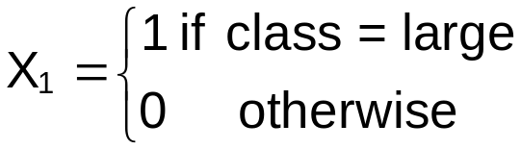

To see exactly how R codes all of the predictor variables, use the contrasts function:

> contrasts(car.data$Class)
Large Mid-Size Mini-Compact Station Wagon Sub-Compact Two Seater
Compact 0 0 0 0 0 0
Large 1 0 0 0 0 0
Mid-Size 0 1 0 0 0 0
Mini-Compact 0 0 1 0 0 0
Station Wagon 0 0 0 1 0 0
Sub-Compact 0 0 0 0 1 0
Two Seater 0 0 0 0 0 1

Here’s a table showing the different indicator variables.

 | X₁ | X₂ | X₃ | X₄ | X₅ | X₆
Compact | 0 | 0 | 0 | 0 | 0 | 0
Large | 1 | 0 | 0 | 0 | 0 | 0
Mid-Size | 0 | 1 | 0 | 0 | 0 | 0
Minicompact | 0 | 0 | 1 | 0 | 0 | 0
Station Wagons | 0 | 0 | 0 | 1 | 0 | 0
Subcompact | 0 | 0 | 0 | 0 | 1 | 0
Two-seater | 0 | 0 | 0 | 0 | 0 | 1

By default, R will put the levels of a qualitative variable in alphabetical order and set the first level to 0 for all indicator variables. Thus, “Compact” is the base level from which comparisons are made to.

To see the ordering among the levels of class, the levels() function can be used:

> levels(car.data$Class)
[1] "Compact" "Large" "Mid-Size" "Mini-
Compact" "Station Wagon" "Sub-Compact"
[7] "Two Seater"

The sample regression model is:

= 30.7312 – 5.0090X₁ – 2.3749X₂ – 3.2312X₃ + 0.07963X₄ – 0.05792X₅ – 5.6201X₆.

A more descriptive way of writing this model is:

 = 30.7312 – 5.0090Large – 2.3749Mid-size – 3.2312Mini-compact + 0.07963StationWagon – 0.05792Sub-compact – 5.6201Two-seater.

Questions:
- Is class linearly related to MPG?
2.What is the estimated MPG for compact cars?
- What is the estimated MPG for two-seaters?
- Which car gets the worst gas mileage?

To estimate the mean response for a class, we can use the predict() function again:

> predict(object = mod.fit, newdata = data.frame(Class =
"Compact"), se.fit = TRUE, interval = "confidence",
level = 0.95)
$fit
fit lwr upr
1 30.73118 29.78848 31.67389

$se.fit
[1] 0.4794041

$df
[1] 369

$residual.scale
[1] 4.623205

Notice that = 30.73, which is exactly the same as the sample mean for compact cars!

Additional output:

> mpg.compact<-car.data$MPG[car.data$Class == "Compact"]
> t.test(x = mpg.compact, conf.level = 0.95)

One Sample t-test

data: mpg.compact
t = 63.6215, df = 92, p-value < 2.2e-16
alternative hypothesis: true mean is not equal to 0
95 percent confidence interval:
29.77184 31.69052
sample estimates:
mean of x
30.73118

> sd(mpg.compact)/sqrt(length(mpg.compact))
[1] 0.4830313

Notes:
- The confidence interval using the sample regression model is a little smaller in width than the “usual” t-based interval that you learned about in STAT 801. What are the differences between the formulas?
- 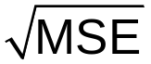 = 0.4794 which is a little less than 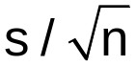 = 0.4830
- An important advantage to using the sample regression model rather than analyzing MPG one class at a time is that you obtain one overall measure of the importance of class.
- Another important advantage is that one can easily incorporate other important predictor variables into the analysis with a sample regression model.

Suppose you wanted to compare the mean of compact to the mean of large.

μ_{compact}: E(Y) = β₀
μ_{Large}: E(Y) = β₀ + β₁

Thus, μ_{Large} – μ_{compact} = β₁. A test of H₀: β₁ = 0 vs. H_{a}: β₁ ≠ 0 tests for equality of means. From the output, we see that the p-value was 3.25∗10⁻⁵. There is strong evidence of a difference in mean MPG for large and compact cars. Compare this result back to the box and dot plot.

Are there mean MPG differences between compact and the other car classes?

To compare classes other than compact, we can use the following methods:
- Use the relevel() function to change the base level:

To compare to the Large class:

> car.data$Class<-relevel(x = car.data$Class, ref =
"Large")
> levels(car.data$Class)
[1] "Large" "Compact" "Mid-Size" "Mini-
Compact" "Station Wagon" "Sub-Compact"
[7] "Two Seater"
> mod.fit.relevel<-lm(formula = MPG ~ Class, data =
car.data)
> summary(mod.fit.relevel)

Call:
lm(formula = MPG ~ Class, data = car.data)

Residuals:
Min 1Q Median 3Q Max
-12.111 -2.947 -0.500 2.290 21.644

Coefficients:
Estimate Std. Error t value Pr(>|t|)
(Intercept) 25.7222 1.0897 23.605 < 2e-16 ***
ClassCompact 5.0090 1.1905 4.207 3.25e-05 ***
ClassMid-Size 2.6341 1.1971 2.200 0.02840 *
ClassMini-Compact 1.7778 1.4694 1.210 0.22709
ClassStation Wagon 5.0886 1.3286 3.830 0.00015 ***
ClassSub-Compact 4.9510 1.1828 4.186 3.56e-05 ***
ClassTwo Seater -0.6111 1.5411 -0.397 0.69193
---
Signif. codes: 0 ‘***’ 0.001 ‘**’ 0.01 ‘*’ 0.05 ‘.’ 0.1 ‘ ’ 1

Residual standard error: 4.623 on 369 degrees of freedom
Multiple R-squared: 0.1271, Adjusted R-squared: 0.1129
F-statistic: 8.958 on 6 and 369 DF, p-value: 3.831e-09

Notice the p-value for Compact is exactly the same as it was before. Also, the b₁ estimate is 5.009 for Compact, where the estimate for Large was -5.009 with the previous model.

All confidence intervals for E(Y), prediction intervals Y, and values of remain the same as before.

- Use the multcomp package

> library(package = multcomp)
> #Large vs. Mid-size cars - Contrast between E(Y) = beta0
+ beta1 and E(Y) = beta0 + beta2
> K<-matrix(data = c(0,1,-1,0,0,0,0), nrow = 1, ncol = 7,
byrow = TRUE)
> compare.means<-glht(model = mod.fit, linfct = K)
> summary(compare.means, test = adjusted("none"))

Simultaneous Tests for General Linear Hypotheses

Fit: lm(formula = MPG ~ Class, data = car.data)

Linear Hypotheses:
Estimate Std. Error t value Pr(>|t|)
1 == 0 -2.634 1.197 -2.2 0.0284 *
---
Signif. codes: 0 ‘***’ 0.001 ‘**’ 0.01 ‘*’ 0.05 ‘.’ 0.1 ‘ ’ 1
(Adjusted p values reported -- none method)

> #Large vs. Mid-size and Large vs. Compact
> K<-matrix(data = c(0,1,-1,0,0,0,0,
0,1, 0,0,0,0,0), nrow = 2, ncol = 7,
byrow = TRUE)
> compare.means<-glht(model = mod.fit, linfct = K)
> summary(compare.means, test = adjusted("none"))

Simultaneous Tests for General Linear Hypotheses

Fit: lm(formula = MPG ~ Class, data = car.data)

Linear Hypotheses:
Estimate Std. Error t value Pr(>|t|)
1 == 0 -2.634 1.197 -2.200 0.0284 *
2 == 0 -5.009 1.190 -4.207 3.25e-05 ***
---
Signif. codes: 0 ‘***’ 0.001 ‘**’ 0.01 ‘*’ 0.05 ‘.’ 0.1 ‘ ’ 1
(Adjusted p values reported -- none method)

> K<-matrix(data = c(0,1,-1,0,0,0,0,
0,1, 0,0,0,0,0), nrow = 2, ncol = 7,
byrow = TRUE)
> compare.means<-glht(model = mod.fit, linfct = K)
> summary(compare.means, test = adjusted("bonferroni"))

Simultaneous Tests for General Linear Hypotheses

Fit: lm(formula = MPG ~ Class, data = car.data)

Linear Hypotheses:
Estimate Std. Error t value Pr(>|t|)
1 == 0 -2.634 1.197 -2.200 0.0568 .
2 == 0 -5.009 1.190 -4.207 6.49e-05 ***
---
Signif. codes: 0 ‘***’ 0.001 ‘**’ 0.01 ‘*’ 0.05 ‘.’ 0.1 ‘ ’ 1
(Adjusted p values reported -- bonferroni method)

The sample regression model here is equivalent to what is often referred to as a single-factor ANOVA model. The ANOVA model is sometimes written as

E(y) = μ + α_{i} for i = 1, …, 7

where μ is the “grand mean” and α_{i} is a parameter representing the deviation from the grand mean for each car class. Similar to what we did for the regression model, the α₁ is set to 0 for compact cars so that we have

 | Model
Compact | E(Y) = μ
Large | E(Y) = μ + α₂
Mid-Size | E(Y) = μ + α₃
Minicompact | E(Y) = μ + α₄
Station Wagons | E(Y) = μ + α₅
Subcompact | E(Y) = μ + α₆
Two-seater | E(Y) = μ + α₇

Thus, μ is equivalent to our β₀, α₂ is equivalent to our β₁, …, and α₇ is equivalent to our β₆.

STAT 802 discusses ANOVA models in more detail.

Suppose there is a qualitative variable of interest that has numbers for its values. While there is no variables like this here, suppose we treat Cylinders as it if were. Examine the two sets of output below.

> mod.fit1<-lm(formula = MPG ~ Cylinders, data =
car.data)
> summary(mod.fit1)

Call:
lm(formula = MPG ~ Cylinders, data = car.data)

Residuals:
Min 1Q Median 3Q Max
-7.95345 -1.95345 0.04655 1.36348 18.04655

Coefficients:
Estimate Std. Error t value Pr(>|t|)
(Intercept) 40.2704 0.6733 59.81 <2e-16 ***
Cylinders -2.0792 0.1243 -16.72 <2e-16 ***
---
Signif. codes: 0 '***' 0.001 '**' 0.01 '*' 0.05 '.' 0.1 ' ' 1

Residual standard error: 3.718 on 374 degrees of freedom
Multiple R-Squared: 0.4278, Adjusted R-squared: 0.4263
F-statistic: 279.7 on 1 and 374 DF, p-value: < 2.2e-16

> mod.fit2<-lm(formula = MPG ~ factor(Cylinders), data =
car.data)
> summary(mod.fit2)

Call:
lm(formula = MPG ~ factor(Cylinders), data = car.data)

Residuals:
Min 1Q Median 3Q Max
-8.2613 -2.2613 -0.2613 1.7387 17.7387

Coefficients:
Estimate Std. Error t value Pr(>|t|)
(Intercept) 49.000 3.570 13.724 < 2e-16 ***
factor(Cylinders)4 -16.739 3.579 -4.676 4.10e-06 ***
factor(Cylinders)5 -22.286 3.817 -5.839 1.15e-08 ***
factor(Cylinders)6 -21.976 3.584 -6.131 2.24e-09 ***
factor(Cylinders)8 -24.568 3.618 -6.790 4.49e-11 ***
factor(Cylinders)12 -30.800 3.911 -7.875 3.82e-14 ***
---
Signif. codes: 0 '***' 0.001 '**' 0.01 '*' 0.05 '.' 0.1 ' ' 1

Residual standard error: 3.57 on 370 degrees of freedom
Multiple R-Squared: 0.478, Adjusted R-squared: 0.4709
F-statistic: 67.76 on 5 and 370 DF, p-value: < 2.2e-16

> factor(car.data$Cylinders)
[1] 5 6 6 6 4 4 4 6 6 4 4 6 6 4 4 6 6 6 6 8 8 6 6 6 6 4 4 6 6 8 8 8
[33] 12 8 6 6 6 6 4 4 6 6 6 6 6 6 4 4 6 6 4 6 6 6 6 6 6 6 6 8 6 8 8 4

Edited

[353] 6 6 4 4 4 4 6 6 6 4 4 4 4 6 4 4 6 5 5 5 5 5 6 5
Levels: 3 4 5 6 8 12

> contrasts(factor(car.data$Cylinders))
4 5 6 8 12
3 0 0 0 0 0
4 1 0 0 0 0
5 0 1 0 0 0
6 0 0 1 0 0
8 0 0 0 1 0
12 0 0 0 0 1

The first model is = 40.2704 – 2.0792Cylinders where Cylinders is treated correctly as a quantitative variable. For illustrative purposes only, one can have Cylinders treated as a qualitative variable by using the factor() function. The second model does and creates 5 indicator variables to represent the 6 different cylinder values in the data set.

Question: Why is treating Cylinders as a quantitative variable better?

8.4 Some considerations in using indicator variables

Please read on your own.
8.5 Modeling interactions between quantitative and qualitative variables and 8.6 More complex models

The interaction terms between a quantitative and qualitative variable involves all indicator variables multiplied by the quantitative variable.

The interaction terms between two qualitative variables involves all of their corresponding indicator variables multiplied by each other. Thus, if the first variable has c levels and the second variable has d levels, there are (c-1)∗(d-1) terms needed to represent their interaction.

Example: Car Highway MPG (car_mpg.R)

Suppose engine size and class are used to predict MPG.

> mod.fit3<-lm(formula = MPG ~ Engine + Class + Engine:Class, data
= car.data)
> summary(mod.fit3)

Call:
lm(formula = MPG ~ Engine + Class + Engine:Class, data = car.data)

Residuals:
Min 1Q Median 3Q Max
-8.0764 -2.0802 -0.3274 1.5063 19.0958

Coefficients:
Estimate Std. Error t value Pr(>|t|)
(Intercept) 41.1196 1.2338 33.327 < 2e-16 ***
Engine -4.3835 0.4969 -8.822 < 2e-16 ***
ClassLarge -0.8976 4.6215 -0.194 0.846113
ClassMid-Size -5.3575 1.9689 -2.721 0.006821 **
ClassMini-Compact -2.6585 3.0719 -0.865 0.387385
ClassStation Wagon 8.7483 3.1419 2.784 0.005644 **
ClassSub-Compact -2.9217 1.5431 -1.893 0.059096 .
ClassTwo Seater -10.4879 2.2823 -4.595 5.97e-06 ***
Engine:ClassLarge 0.8277 1.1822 0.700 0.484299
Engine:ClassMid-Size 1.8267 0.7143 2.558 0.010949 *
Engine:ClassMini-Compact 0.1230 1.1644 0.106 0.915943
Engine:ClassStation Wagon -3.8828 1.3242 -2.932 0.003581 **
Engine:ClassSub-Compact 1.3227 0.6069 2.180 0.029929 *
Engine:ClassTwo Seater 2.6877 0.7270 3.697 0.000252 ***
---
Signif. codes: 0 '***' 0.001 '**' 0.01 '*' 0.05 '.' 0.1 ' ' 1

Residual standard error: 3.553 on 362 degrees of freedom
Multiple R-Squared: 0.4942, Adjusted R-squared: 0.4761
F-statistic: 27.21 on 13 and 362 DF, p-value: < 2.2e-16

The sample model is

= 41.1196 – 4.3835Engine
– 0.8976Large – 5.3575Mid-size – 2.6585Mini-compact + 8.7483StationWagon – 2.9217Sub-compact – 10.4879Two-seater
+ 0.8277Engine∗Large + 1.8267Engine∗Mid-size + 0.1230Engine∗Mini-compact – 3.8828Engine∗StationWagon +
1.3227Engine∗Sub-compact +
2.6877Engine∗Two-seater

A partial F test can be performed to determine if the interaction term is needed in the model. Let α = 0.05.

> mod.fit.red<-lm(formula = MPG ~ Engine + Class, data =
car.data)

> anova(mod.fit.red, mod.fit3)
Analysis of Variance Table

Model 1: MPG ~ Engine + Class
Model 2: MPG ~ Engine + Class + Engine:Class
Res.Df RSS Df Sum of Sq F Pr(>F)
1 368 4994.1
2 362 4570.1 6 424.0 5.5979 1.432e-05 ***
---
Signif. codes: 0 '***' 0.001 '**' 0.01 '*' 0.05 '.' 0.1 ' ' 1

- H₀: β₈=β₉=β₁₀=β₁₁=β₁₂=β₁₃=0
H_{a}: At least one of the β’s does not equal to 0
-  and p-value = 1.4∗10⁻⁵
- α = 0.05
- Since 1.4∗10⁻⁵ < 0.05, reject H₀
- There is sufficient evidence to indicate an interaction between engine and class.

Since there is only one quantitative variable, we can create a 2D plot of the model. There will be a line on the plot for each class.

Class | Model
Compact | = 41.1196 – 4.3835Engine
Large | = 41.1196 – 4.3835Engine  – 0.8976∗1 + 0.8277Engine∗1  = 40.2220 – 3.5558Engine

Two-seater | = 41.1196 – 4.3835Engine  – 10.4879Two-seater + 2.6877Engine∗1  = 30.6317 – 1.6958Engine

R code:
#Sample model plot
win.graph(width = 6, height = 6, pointsize = 10)
#Compact
curve(expr = mod.fit3$coefficients[1] +
mod.fit3$coefficients[2]*x, col = "red", lty =
"solid", lwd = 2, xlim = c(1,6), ylim = c(0,55), xlab =
"Engine size", ylab = "MPG", main = "MPG vs. engine
size", panel.first = grid(col = "gray", lty = "dotted"))
#Large
curve(expr = mod.fit3$coefficients[1] +
mod.fit3$coefficients[2]*x +
mod.fit3$coefficients[3] +
mod.fit3$coefficients[9]*x, col = "blue", lty =
"solid", lwd = 2, add = TRUE, from = 1, to = 6)

Code excluded

#Two-seater
curve(expr = mod.fit3$coefficients[1] +
mod.fit3$coefficients[2]*x +
mod.fit3$coefficients[8] +
mod.fit3$coefficients[14]*x,
col = "brown", lty = "solid", lwd = 2, add = TRUE, from =
1, to = 6)
legend(locator(1), legend = c("Compact", "Large", "Mid-size",
"Mini-compact", "Station wagon", "Sub-compact", "Two-
seater"), col = c("red", "blue", "green", "orange",
"black", "lightblue", "brown"), lty = rep(x = "solid",
times = 7), bty = "n", cex = 1, lwd = 2)

EASIER WAY: Use predict() with curve(). How can the two be used together?
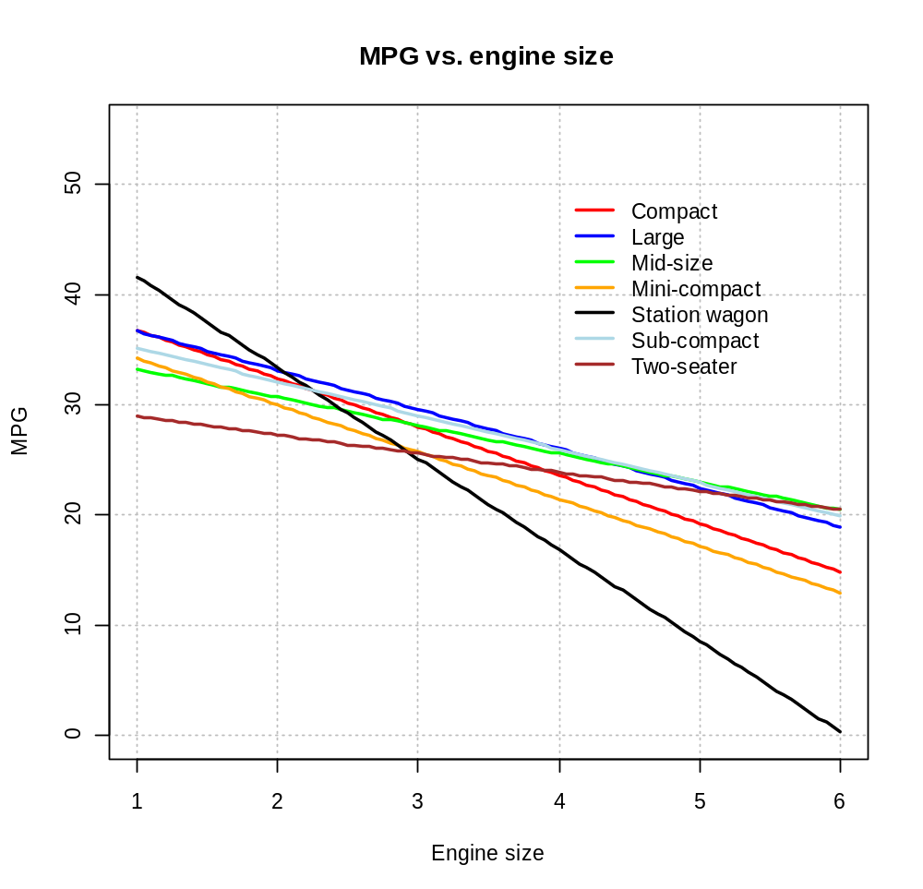

Questions:
- Why are the lines not parallel?
- Is there extrapolation beyond the range of the engine sizes?
- What would you expect the plot to look like if there was not a significant interaction and class effect?

Next are two more plots to help you understand this model and the observed data. For the code, please see the program (make sure to see the use of the recode() function).
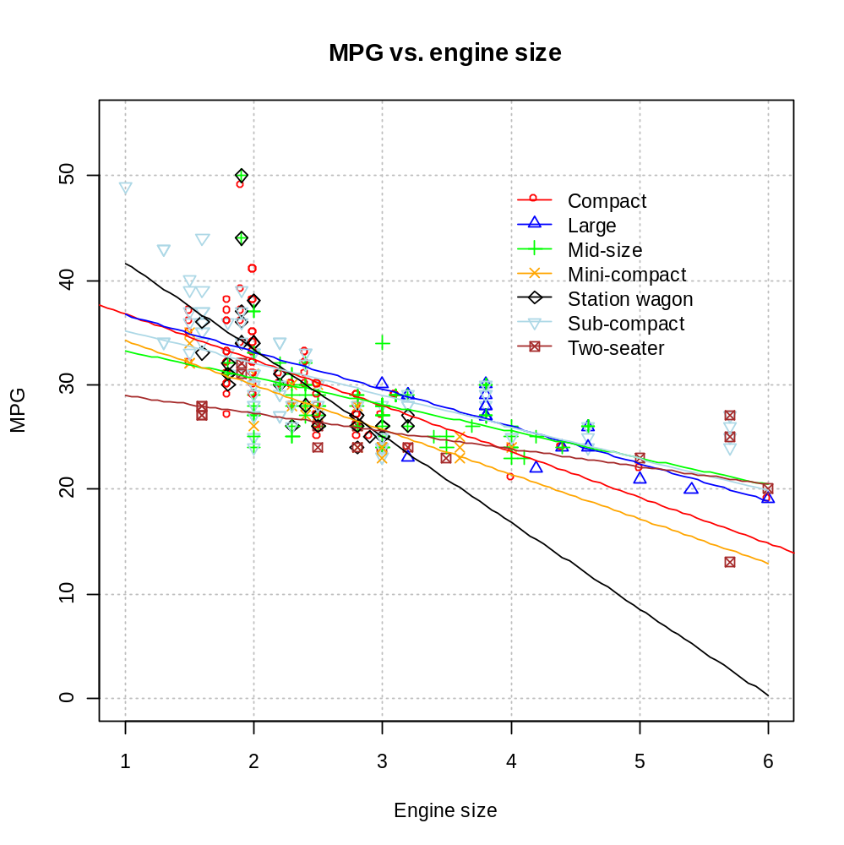

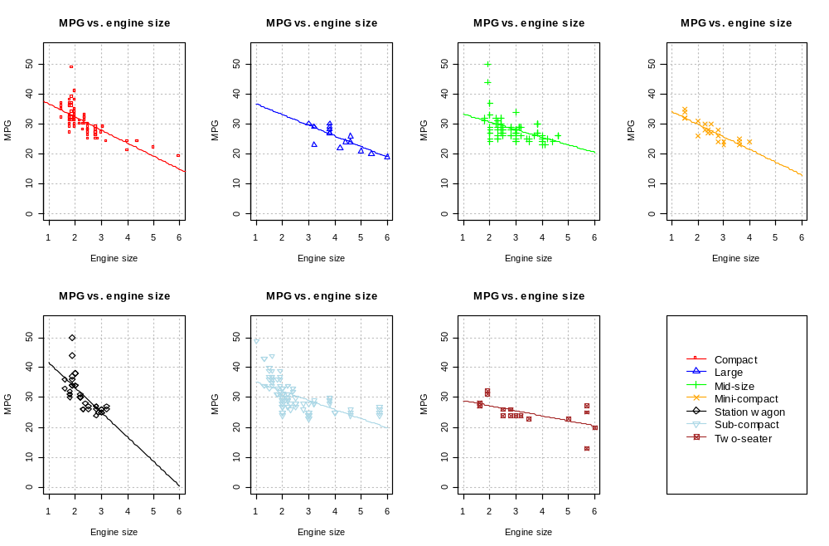

Other notes about qualitative variables:
- Residual vs. indicator variable plots are not necessary since the indicator variable has only 2 levels.
- When both qualitative and quantitative predictor variables are present, the regression models are the same as analysis of covariance (ANCOVA) models.

8.7 Comparison of two or more regression functions

Please read on your own.

